Localization and aaBridge - A How to
Written by Roger Pfister roger@RogerPf.com http://RogerPf.com/aaBridge
There are three sections
1. Getting access to all the .lin files INSIDE aaBridge
including re-zipping – (the hard part)
Inside aaBridge is a large collection of lin files (good examples) and all the translation files for each supported language. You can add a new language or change an existing language translation.
(The original Translations were made with Google translate so could be much improved)
2. Localizing aaBridge's buttons etc into a new Language
including improving an existing translation
For a new language, the first thing to translate is the text of the buttons and other messages that go with the buttons.
Section 2 is the 'How to'.

3. Adding lin files in a new Language (often in non-Latin scripts)
The next thing to consider is translating some lin files into in your language. Obvious candidates are the Welcome Page and the New User - Read me's.
As you will see from the clear examples supplied - aaBridge can have multiple versions of the same lin file but with each in a different language.
Section 3 is the 'How to'.
Section 1. Getting access to all the lin files INSIDE aaBridge
(This is a great source of example lin files.)
Anyone interested in .lin files should first get their aaBridge jar file and UNZIP it. YES aaBridge is just a ZIP with a .jar ending.
Mac and Linux users always start from the .jar file so they will know where it is. Windows users should look in C:\ProgramSmall\aaBridge where you will find the jar file with a name like aaBridge_4.0.0.2952.jar.
If you cannot see the three letter extension (here .jar) see Appendix 2 for 'how to' show them in your system.
Actions
Create a folder anywhere that is convenient for you.
Copy the above jar file (the latest – the highest number) to that folder and
Rename it from .jar to .zip Now you can just use your system unzipper (possibly called Archive manager) to unzip the file into a folder.
Windows users are STRONGLY advised to download and install the free 7zip http://www.7-zip.org/ which will let you unzip the .jar without renaming it.
A "port" of seven zip (free) is also available for the Mac http://www.kekaosx.com/ .
Your expanded aaBridge can run. !!! See the next section, (Section 2);

1.1 Re-zipping aaBridge and making a linzip file
The following sections cover how you can change aaBridge and add new lin files and language support to it, BUT there can be a problem.
If you want to zip-up and re-create an aaBridge .jar with your changes, AND any of the FILENAMES use any non-Latin letters - including accented letters like the French 'ç' (c-cedilla) - there is a good chance that the resulting zip file will not work as a jar in all computers.
(The problem is that the zip specification is so old it does not cover non-Latin characters in filenames.)
The only solution I know (under Windows) is to use the free 7-zip utility (mentioned above) via the command line with the poorly documented -mcu=on setting.
This does the sensible thing and encodes non ACSII filenames in UTF-8.
The command line version of 7zip is available from their site. Create the following .cmd file zip8.cmd (8 to remind you it is UTF-8) and put it in your path. It has only lines
for %%* in (.) do set thisDir=%%~nx*
del "..\%thisDir%.linzip"
"C:\<path to 7zip>\7za.exe" a -mcu=on -tzip "..\%thisDir%.linzip" *
a copy is also in <expanded-aaBridge>\yyy_other\build_extras\zip8.cmd

Open the folder you want to re-zip in a command window and run zip8 the resultant file will be created - one level down - next to the target folder.
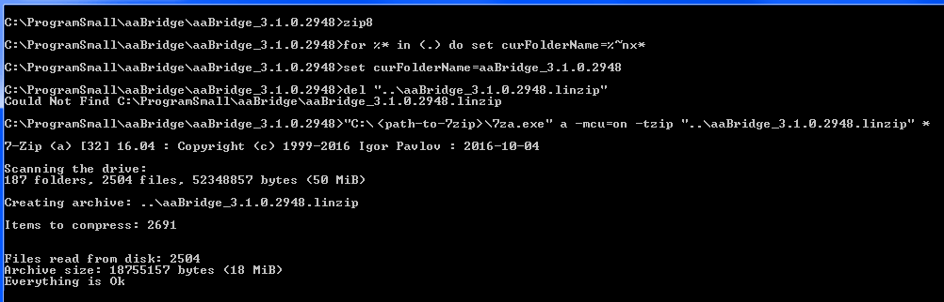
The image above shows it being run. When the resulting file
aaBridge_3.1.0.2948.linzip was renamed to end in .jar it ran perfectly.
Easy way
If you want to make a .linzip (a collection of lin files) and their names are all just Latin characters (English characters) any zip utility will work.
1.2 Alternatively avoid using non-Latin characters in filenames
aaBridge supports a second method of having non-Latin characters displayed in the titles of books and lin files while having only Latin characters in the actual filenames embedded in any zip file. This is covered in Appendix 1.
Note – aaBridge comes with non-Latin characters in some filenames – eg: there are demo Lin files supplied with Chinese characters in the names so the alternative method is best used only for .zips and .linzips.
(A .linzip is a group of lin flies that have been zipped and the files re-named to .linzip. You can drag and drop zip files and linzip files on to aaBridge. Windows users can also double click on linzips to make them open.)
1.3 Lin file Character encoding UTF-8 and ASCII
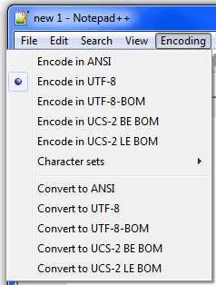
All files must use ASCII or UTF-8 encoding. If you are just writing in English you have nothing extra to do. If you are using any non-Latin characters then you will have to choose an encoding. (Or your editor software will choose one without telling you). Note that as mentioned earlier, characters like the French 'ç' (c-cedilla) are classed as non-Latin script.
For non-Latin scripts aaBridge requires UTF-8 encoding. Of the many encodings UTF-8 is now the hugely popular 'encoding of choice' on the web.
For windows users, an editor that makes this choice easy, is NotePad++ See Appendix 2. for more information.
For an example lin which uses multiple language fonts see Chinese UTF-8 in the left hand column of the aaBridge welcome page.

Section 2. Localizing aaBridge - Buttons, Cards, etc
Localizing the buttons (which here means supplying different language versions for the aaBridge button text and similar items) is a common thing to do. The aaBridge approach does have some additions – for example, choice of the honor card letters AKQJ.
The following description is principally aimed at Windows users. All the same methods work equally well on Mac and Linux, but the positions of files and applications (eg: editors) will vary.
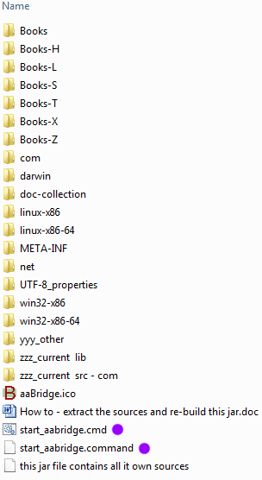
Get the latest .jar eg: from C:\ProgramSmall\aaBridge and (for clarity) unzip it to a folder with the same name as the jar file. See the image on the right.
(Those who want to can rebuild aaBridge from the java sources – see the How to in the list.)
Notice that lin files are put in books. A total of 27 books can exist. These are named: Books, and Books-A to Z, but four (4) – Books and Books-X to Books-Z – are reserved. Do NOT use them.
Other than as stated above, you are free to add new books of your own. How to give your added books, the names you want, is covered in Section 3.
This section deals with the language files that are in the UTF-8_properties folder .
The expanded aaBridge is runnable. Windows users can try dbl-clicking the start_aabridge.cmd file
MAC's users use start_aabridge.command
It is IMPORTANT that you can run aaBridge "expanded". Why ? - because this is the way to test your translation.
2.1 Property files and Language Signifiers
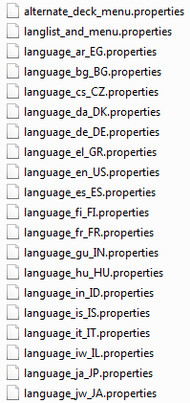
In Java and so in aaBridge, language signifiers (codes) are given as two pairs of characters – first a generic language code, second a region specific code. The first is in lower case and the second in upper case with an underscore between them.
UTF-8_properties
So en_US is English for United States.
If you open the UTF-8_properties folder (from the above list) you will see the current list of 'properties files'. They all have the .properties extension. Files with a name including a pattern like fr_FR contain the translations for that language .
The language_en_US.properties file contains the original source of the translations. This is the 'default language' file as for aaBridge the default language is US English. So that file contains the full list of all the character strings that aaBridge uses. Some systems (not aaBridge) use the simpler style of language.properties as their default language filename.
The file langlist_and_menu.properties contains the language menu. If you add your language signifier to this file and add your new language properties file to the folder (and restart aaBridge) it will show in the language menu.
All the original supplied translation files were translated with Google Translate – and while some are good, some could do with improvement – would you like to help. :)

2.2 The Language Menu
Users can select a language via the Language menu (marked below).

The example inserted menu Book-Z (here re-named by aaBridge) is made visible by the setting at top of the Language Menu (see next page).
2.3 Deck Override Properties
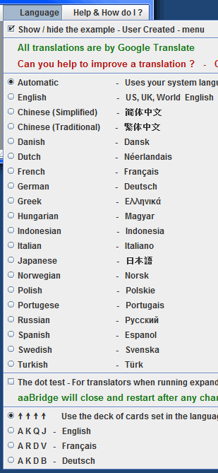
Look at the bottom of the language menu showing on the right and compare with the contents of the file
alternate_deck_menu.properties
languages = en_US, fr_FR, de_DE
en_US = AKQJ, A K Q J - English
fr_FR = ARDV, A R D V - Français
de_DE = AKDB, A K D B - Deutsch
The first line defines the language codes that will be show in the menu and the other lines define the four characters used for the deck (AKQJ) with the actual menu text following the comma.
So a user can select the Dutch language while choosing to playing with the English deck.
You can test if your expanded aaBridge is working correctly.
2.4 A Test (that you might like to try)
Remove de_DE from the language property in the alternate_deck_menu.properties file (Save the file).
Close and restart your "expanded" aaBridge
Check that Deutsch is no longer an entry in the lower part of the Language menu.
2.5 UTF-8 Just a reminder
All files must be encoded in ASCII or UTF-8 (no BOM). Think of ASCII as UTF-8 but happening to have only Latin characters.
2.6 Localizing the Buttons and other Text
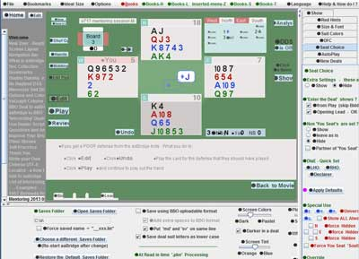
To get a quick idea of the level of localization coverage of the buttons and other text (like tool tip popups) you can:
Open the Language menu and check the
'The Dot Test' option checkbox.
When and ONLY when you run in expanded mode, that setting causes a black dot ● to be added to almost all the translatable text, as shown in the image. (The only translatable text that is NOT shown with dots are the cards AKQJ and the four directions NSEW).
2.7 How to Start your Translation
Assuming your language code is ab_CD you need to Edit the
langlist_and_menu.properties file and
Add in a menu entry for your language, don't forget the hyphen.
If you are improving an existing translation you can now start editing the property file for that language. If your language is completely new to aaBridge then
Copy the file language_en_US.properties to language_ab_CD.properties
Set the first two property values to 'true'
control.reportMissing = true
control.reportBlank = true
The first real entries start below . . .
Some entries can have codes
game.akqj = <RPf>[4] ARDV
game.nt = <RPf>[2] SA
game.pass = <RPf>[5] pas
game.dealer = <i>[1] D
game.nsew = <RPf>[4] NSEO
game.north = <g> Nord
There are three code fields that can come after the equal signs
property.name = <T>[N]{I} translation
<T> source of the Translation
'g' = Google Translate
'i' = Original value, set by {def}
'RPf' = Roger Pfister (example)
'???' = Translators Initials

[N] shows SHORT text is wanted N is the MAX size in characters.

{I} Info has many uses
'blank' = The translator wants the value EMPTY
'x' = NOT used by aaBridge
'def' = creates Orig value in language.properties

REMEMBER when you add / change a translation
ADD your initials so when you send it to me I can stop Google Translate from changing it .
In the language_en_US.properties file you will find additional text <<<T>>>> after the marker. For example
menuFile.exit = Exit <<<T>>> To Exit
These are just used by other software to give Google alternate text.

2.8 Test as you Translate
Clearly you can save the file at any time and run aaBridge (in expanded mode) to verify how your translation works. If you set
control.dotShowFallback = true
then you will see the dot on any entries that are missing the keys and had to instead use the entry from the default language (en_US) file (as shown earlier).
If you set
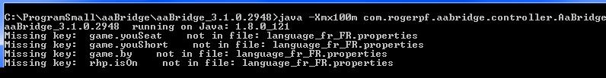
control.reportMissing = true
control.reportBlank = true
And run aaBridge from expanded mode OR by starting the .jar from a command line then you see many messages like those above, which may be of help to you.

2.9 How Much to Translate ?
How much to translate for a new language ? – is up to you. I would think that a good start would be the major buttons (not their accompanying _TT, tooltips) and perhaps the Welcome page and a page or two from the New User README.
So translate as much as you think worth doing.
A big thank you for doing anything at all.
If you do make changes please send a copy (of the changed files) to me at roger@rogerpf.com

Section 3. Localizing Lin Files (like the Welcome page)
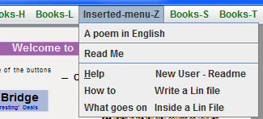
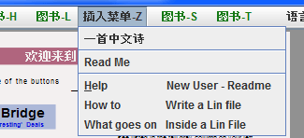
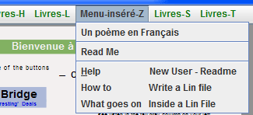
In build 2952 aaBridge has a demo "user inserted menu" (with lin files). This can be made visible or hidden with the option at the top of the language menu.
This menu and example lin files covers three languages English, French and
Chinese (Simplified).
In the right-hand column you can see the inserted menu showing first in English, then in French, and finally in Chinese.
By changing the language using the language menu (shown earlier) you will be able to see all three versions as shown in the images.
Notice also that the menu bar has been translated into the 3 different languages.
A start has been made on customizing the welcome page itself – the word 'Welcome' shows in the appropriate language.
Also, please note that the first entry in the grey left-hand column is in the correct language. (Not shown in images).

Please try the following (for each language) go into the book / menu option called
'A poem in English' and notice that the first file under that 'book' is in the appropriate language and that the other .lin files of the other languages do NOT show.
Compare this to the second file in that folder which is the same for all three languages.
3.1 The Books-Z demo folder
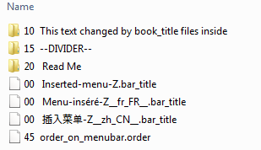
This section shows you how you can have different language title version showing for menus, books and chapter (lin file) names.
Look in your expanded aaBridge folder and go into the Books-Z folder. You should now see something like the image on the right. Notice that the three different menubar titles that you could see in the images on the previous page have been taken from the three file names that have a .bar_title extension. These overrule the default name of Books-Z
The language code must be appended in the form __ab_CD__ (note the preceding and trailing double underscores).
The .order extension is used to place the position of the menu. 1 is to the far left and 99 is to the far right. If not supplied the default is 50. Any menus with the same position number are placed next to each other in alphabetical order left-to-right.
Important - when you create .bar_files or any files like these they must contain exactly a single character. I recommend the letter 'x' in lower case.

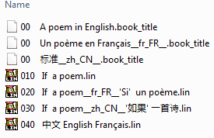
3.2 The This text changed... folder
Look in the 10 This text changed... folder it should look something like the image on the right.
The first three entries (starting '00') and this time ending in .book_title are what sets the title for the 'book' stopping it from being called
'This text changed...'.

(continued on next page)
Three DIFFERENT poem .lin files (one for each language) are also shown. Notice that for the lin files the number does not matter (so you can control the order), what matters is that the English version of the title is IDENTICAL for all three and that the language code __ab_CD__ separates the English name from its true language name.
So depending on which language the user has selected they will be shown the correct language version of that lin file with it title showing in the correct language.

3.3 Summary
You can override the (folder) name of the menu in the menubar (eg: Books-Z) by using the .bar_title extension. You can have variations for each language by using the language specifier.
00 Inserted-menu-Z.bar_title
00 插入菜单-Z__zh_CN__.bar_title
You can override the (folder) name of a menu entry in a menu
(eg: 10 This folder name changed ...) by using the .book title extension. You can have variations for each language by using the language specifier.
00 A poem in English.book_title
00 一首中文诗__zh_CN__.book_title

Given you have a file (Eg: 010 If a poem.lin) you can provide language specific versions of that lin file. Also with the language specifier you can set its name while still having it associated with the original lin file.
010 If a poem.lin
030 If a poem__zh_CN__'如果' 一首诗.lin

4 General points when Translating
The format of the .properties file has to follow the spec set by Java. See
https://docs.oracle.com/cd/E23095_01/Platform.93/ATGProgGuide/html/s0204propertiesfileformat01.html
Please use the propertyName = value format with aaBridge.
As the spec says, spaces before value are removed but spaces AFTER value are kept.
If you want to add spaces in front of value You can use the unicode spaces directly as a character. (Your properties file MUST be encoded in UTF-8)

4.1 aaBridge only Features
propertyName = <fb>
Will fallback to the English version and not generate any warning messages.
propertyName = . (single period / full stop)
Will use the empty string.
Note that by default propertyName =
will fallback to the English version and if it can, report a 'blank' value warning.

4.2 Groups of names
Some names come in groups
instruct.play1 = .
instruct.play2 = PLAY by clicking on a CARD
instruct.play3 = or by using your Keyboard.
instruct.play4 = .
instruct.play5 = Gray dots => click on green
As the translator you are free to use any of the five lines in a way that suits your language to convey the meaning. With propertyName = . as the way to leave a line blank.

4.3 Internal Links - do not change
If you do choose to translate any of the standard aaBridge files such as the Welcome page, you should leave any internal links in the files pointing to the English language version. aaBridge will automatically use to the appropriate version language if it exists.

4.4 Un-available for translation
There are a few items currently unavailable for translation. For example when aaBridge reads in a .pbn file it adds an informational page to the automatically produced .lin file. As this page is of no real content it will always be English only.
Some letter commands like pf!! inject English text into the display of the Lin file. As this is all they do the simple solution is to not use those commands unless you are writing in English. Instead just put the text you want into your the lin file

4.5 When you have finished
If you would like your translation included in aaBridge please send your work to me
roger@RogerPf.com
Many thanks in advance for your contribution.

Appendix 1. Alternative way of getting non-Latin file names
Two additional zip files are provided in the aaBridge document collection. See the left-hand grey column on the welcome page. The files are:
Books-Y.zip
Books-Z.zip
the second file is a zip of the Books-Z described earlier and is built into aaBridge. The first file Books-Y.zip has nearly identical contents but provides a different mechanism by which you can display the names you want to see without having non-Latin characters in the actual filenames.
Using the techniques covered in a Section 2, you can unzip Books-Y.zip and add it into your expanded aaBridge. You will see that it is nearly identical to Books-Z.
Alternatively, but less desireable, a quick test is to drag and drop it onto aaBridge, but this will not show as clearly.
Below are comparisons of contents of the two zip folders.
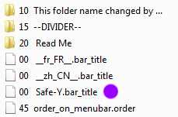
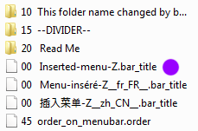
Books-Z.zip Books-Y.zip

In the two examples the ENGLISH menu name that can show on the Menubar is set with a file using the .bar_menu extension and NO language modifier. (Purple dots).

In the Books-Z case there is an additional language text variant of that file in which (as covered earlier) the alternative names come BEFORE the language specifier.
Notice that in Books-Y the alternate language text is missing (blank) so instead aaBridge will read the first line of the file and use the text found there.

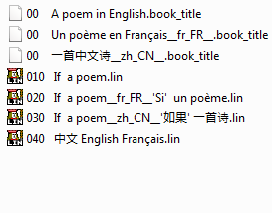
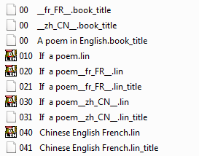
Books-Z.zip 10 This folder... Books-Y.zip 10 This folder...

The above images are of the two folders named '10 This folder ...'
Looking at the folders shows that the .book_title extension uses the same scheme as described earlier. So if there is no text before the language specifier then the first line of the file will be read and its contents used.
If you now look at the three language variants of the same .lin file you can see that a similar scheme operates, except the language text is expected to come after the language specifier. This time if language text is missing then the English version will be used. Additionally you can supply a matching .lin_title file that will have its first line read.

Notice that aaBridge requires that for lin files the standard language (English) name must be present in all files that refer to the same target lin. This includes .lin extension and .lin_title extension.

Also notice that the ordering group of digits are NOT used to identify a file or folder.
You can have non-Latin characters in the default (English) name files 040... and 040... / 041... the above tables show this. However if you wish to make an internal link to any Lin files using the ^*g .... ^*n lin commands then you are strongly recommended to only use Latin characters in the default language filename.

Appendix 2. Lin files – What you need to Write them
Written by Roger Pfister roger@RogerPf.com http://RogerPf.com/aaBridge
See aaBridge menubar > Help & How Do I > Write Lin File (bottom of menu)
To write Lin files you basically need three things
- A program that will play them (aaBridge).
- An editor that lets you edit them easily.
- Adjustments to your computer (for an easy life).
The next few lines go into details for Windows and Mac.

If you are running Windows
1. Install the latest aaBridge If you have any problems do contact me.
As always, it can be downloaded from http://RogerPf.com/aaBridge
2. Please get and install the wonderful Free text editor. NotePad++
https://notepad-plus-plus.org/
3. Set you computer to show the 'extensions' at the end of filenames. See
http://windows.microsoft.com/en-us/windows/show-hide-file-name-extensions

If you are running Mac OSX
1. Install the latest aaBridge If you have any problems do contact me.
As always, it can be downloaded from http://RogerPf.com/aaBridge
2. Please get and install the Free text editor. TextWrangler
http://www.barebones.com/products/textwrangler/download.html
3. Set you computer to show the 'extensions' at the end of filenames. See
https://support.apple.com/kb/PH19072?locale=en_US
<end document>

